EXERCICIO 04

select TOP(1) Funcionarios.nome, Departamentos.dep_nome as setor, Funcionarios.salario as salario from Funcionarios inner join Departamentos on

Funcionarios.dep_id = Departamentos.dep_id where Funcionarios.nome like 'D%' order by salario desc;

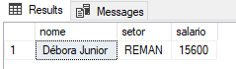

EXERCICIO 05

select Funcionarios.nome, Departamentos.dep_nome as Departamento, Departamentos.dep_local as Local_Trabalho from Funcionarios inner join

Departamentos on Funcionarios.dep_id = Departamentos.dep_id;

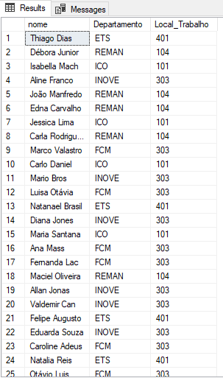

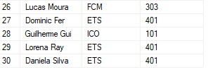

EXERCICIO 06

select sum(salario) as Func_Jonas_salarios from Funcionarios where lider = 'Jonas'

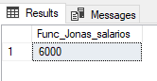

delete from Funcionarios where lider = 'Jonas'

select count(dep_id) as funcionarios_restantes from Funcionarios where dep_id = 5

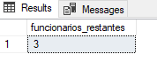

UPDATE Funcionarios

SET salario = salario+(6000 / 3)

WHERE dep_id = 5;

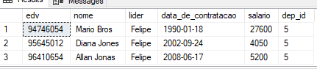

EXERCICIO 07

select TOP(1)Funcionarios.edv, Funcionarios.nome, Funcionarios.lider,salario,Grade_salarial.grade from Funcionarios, Grade_salarial

where Funcionarios.Salario >= Grade_salarial.sal_min and Funcionarios.salario <= Grade_salarial.sal_max

order by data_de_contratacao;

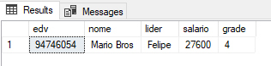

EXERCICIO 08

select count(Funcionarios.edv) as quantidade_Funcionarios, Departamentos.dep_nome as Setor from Funcionarios

inner join Departamentos on Funcionarios.dep_id = Departamentos.dep_id where Funcionarios.salario > 4000 group by dep_nome;

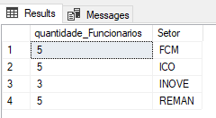

EXERCICIO 09

UPDATE Funcionarios

SET lider = 'Marcos'

WHERE lider = 'Lucio';

select nome,edv from Funcionarios where data_de_contratacao >= '2015' and lider = 'Marcos' or lider = 'Captu'

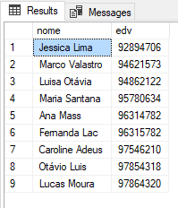

EXERCICIO 10

select avg(Funcionarios.salario) as Média_salarial,

max(Funcionarios.salario) as Maior_Salario,

min(Funcionarios.salario) as Menor_Salario, Departamentos.dep_nome as Departamento from Funcionarios

inner join Departamentos on Departamentos.dep_id = Funcionarios.dep_id

group by dep_nome;

